|  |
| --- |
|  |
| SENG 21253  Web Project |
| |  |  |  | | --- | --- | --- | | B.V.P. Fernando | 8/1/18 | SE/2015/047 | |

**Table of Content**

**Problem** 2

**Solution** 2

**Functionalities** 3

❖ View Product by Categories 3

❖ View new movies and games 3

❖ For a particular movie or game, **watch the trailer** 4

❖ View mobile phones and accessories 5

❖ For a particular mobile phone, view the full specification 6

❖ Find the location by Map 7

❖ Contact by sending an Email 7

**HTML Pages** 8

Index.html 8

home.html 11

About.html 17

Contact.html 18

Movies.html 20

Games.html 22

Phone.html 24

Accessories.html 26

Table.css 28

Action.php 29

Movies(1 - 12.html) & Games(1 – 9.html) 30

# **Problem**

* There are lot of communication centers and phone shops for a town. But it is very difficult to find a reliable place to purchase a mobile phone or accessories. Therefore, as the customers we have to find out a suitable place.
* Most of the people are willing to watch movies and play games. So we need an always updating place for this purpose. Customers always search for finding out a suitable place for purchasing latest movies and games.

# **Solution**

* Since, internet is the best place for finding something, people usually search about the communication centers and phone shops as well. So it is good to have a web site for a communication center or a phone shop. Then people can search about the place and their services. As well as, for owners, it is easy to spread among people, their services features and importantly, show how much people can rely on them.
* Also owners can promote their products, brands via the web site. It is the best way of marketing currently with the always changing technology.

# **Functionalities**

## View Product by Categories

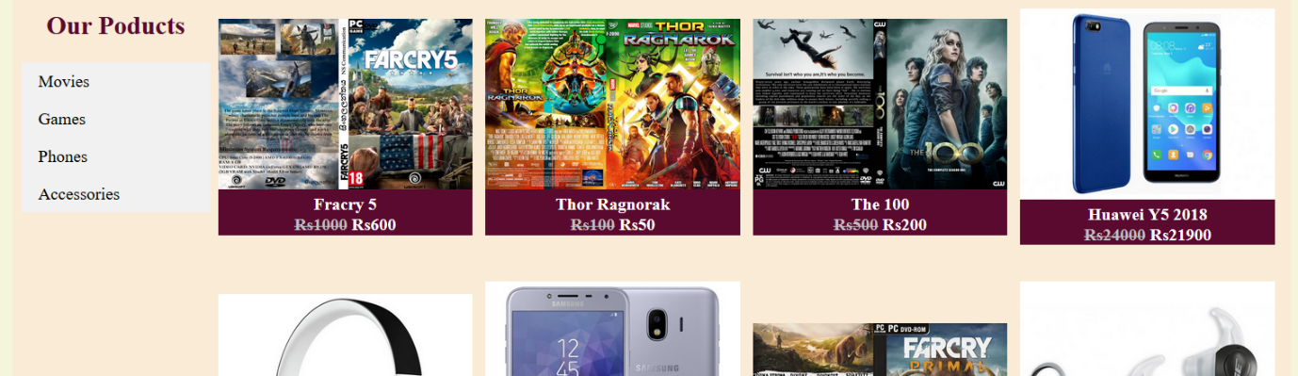

## View new movies and games

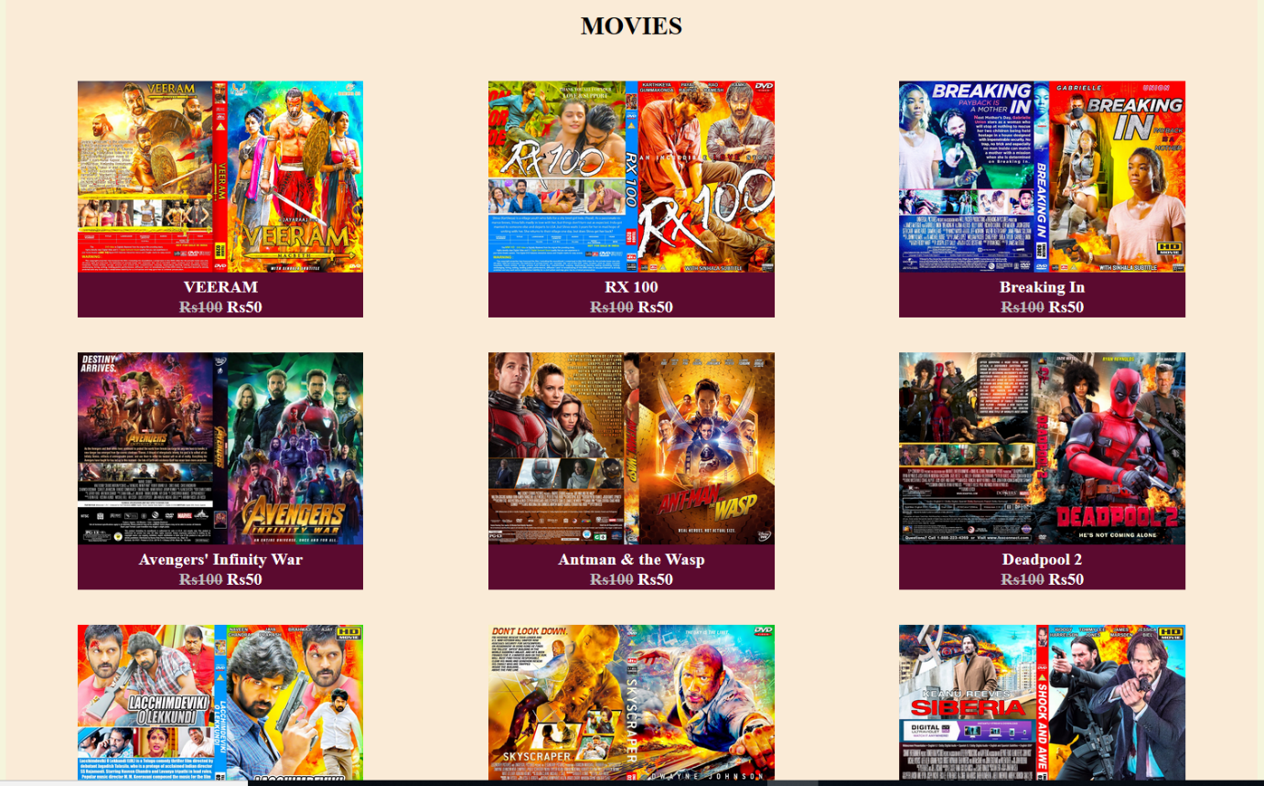

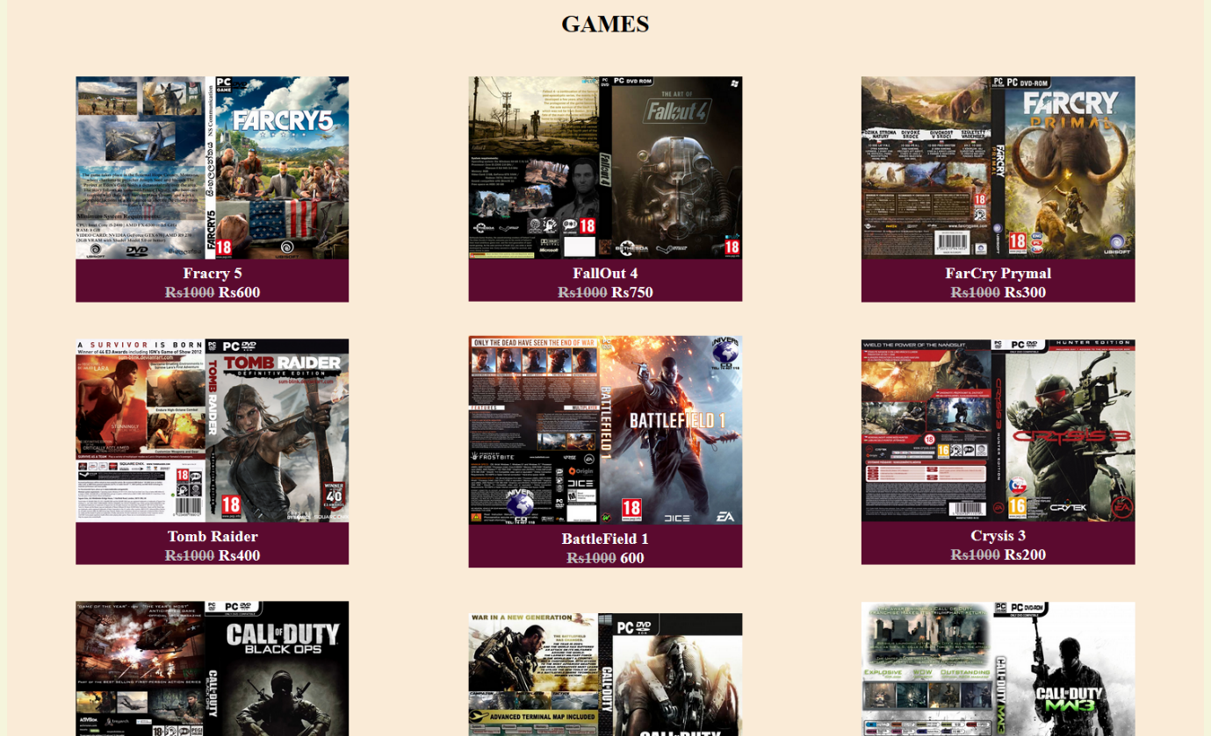

## For a particular movie or game, **watch the trailer**

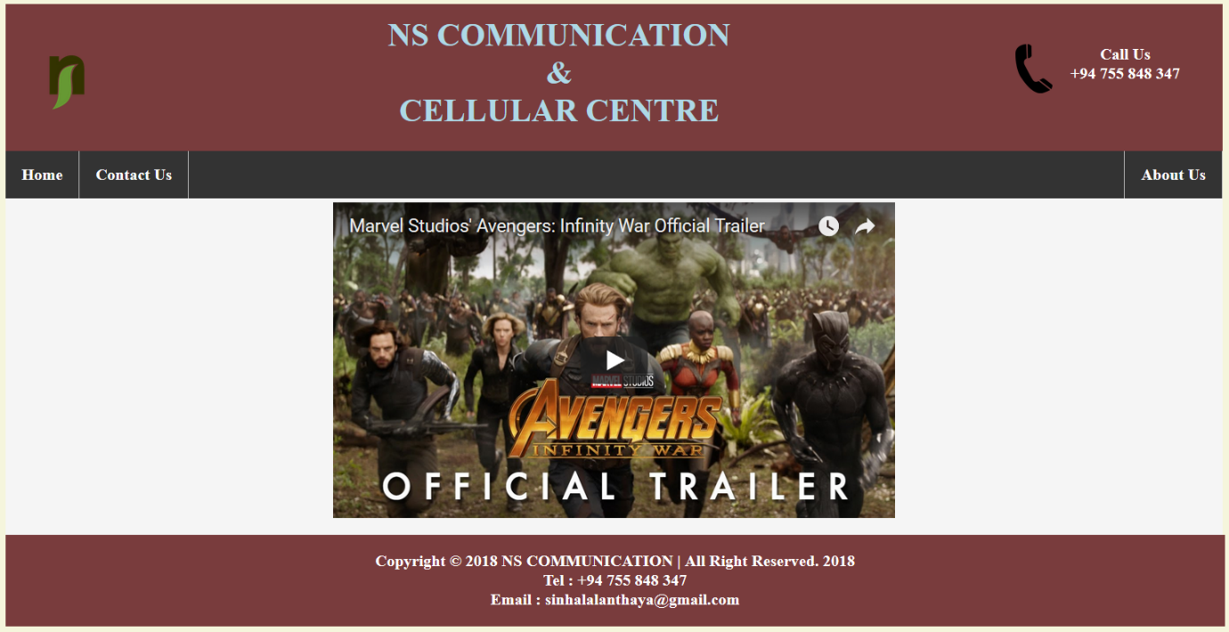



## View mobile phones and accessories

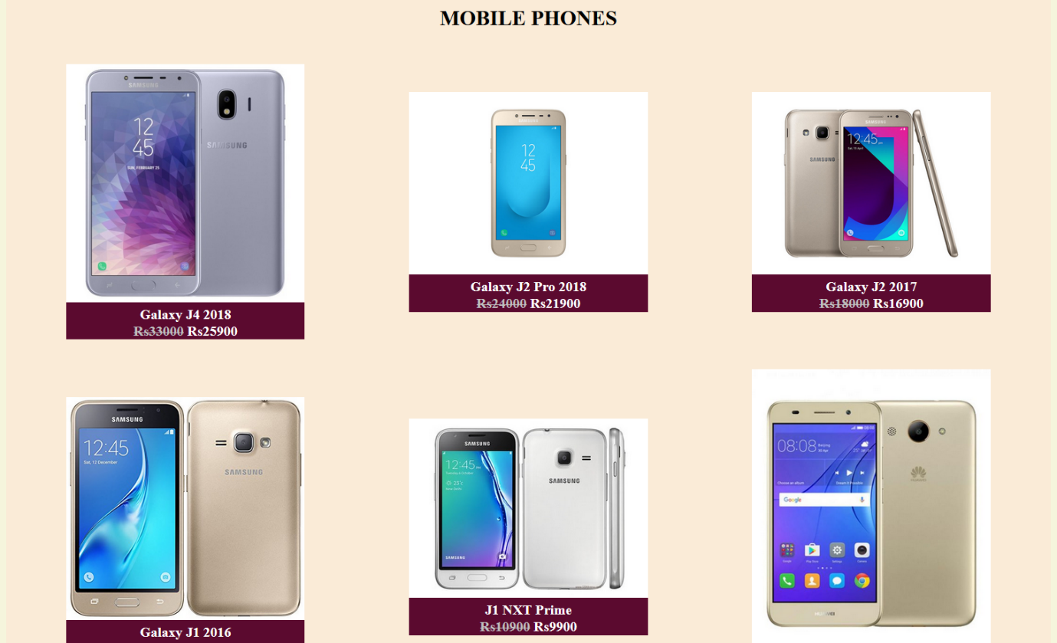

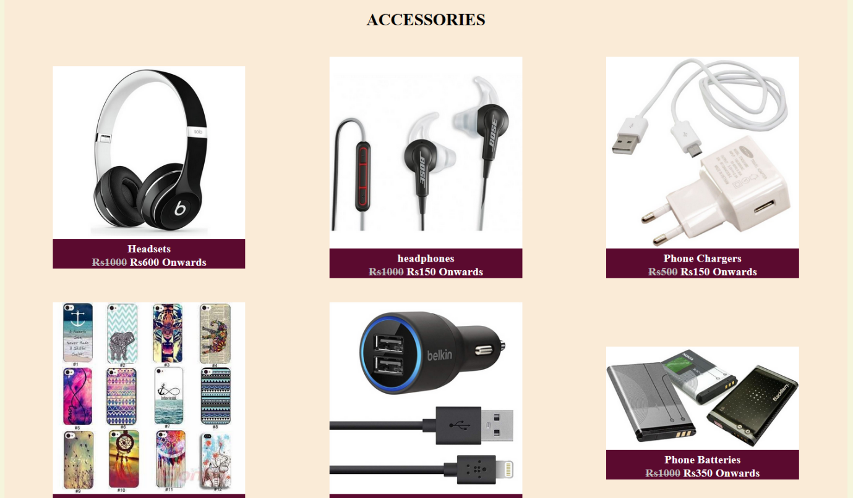

## For a particular mobile phone, view the full specification

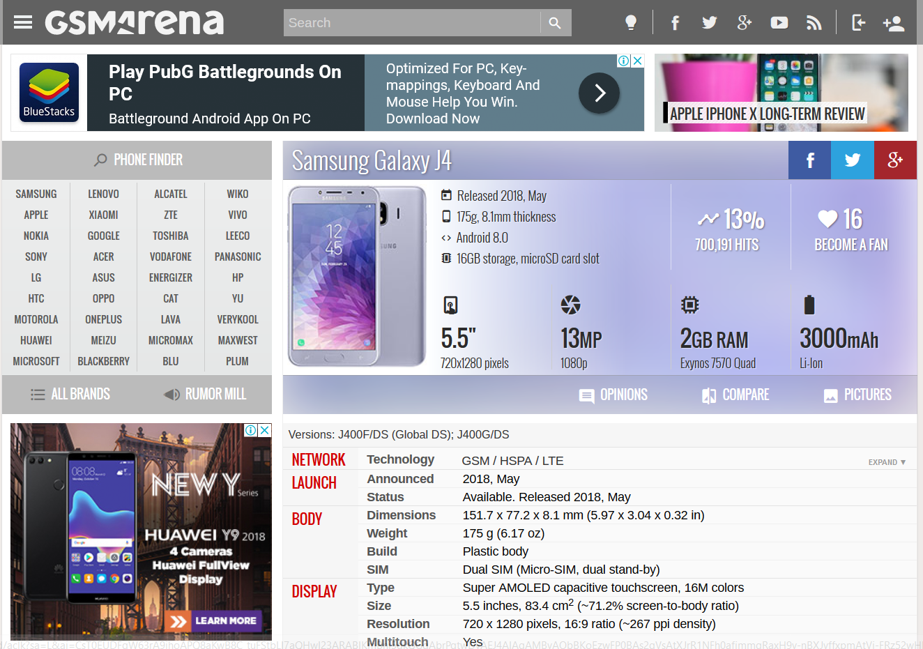

## Find the location by Map

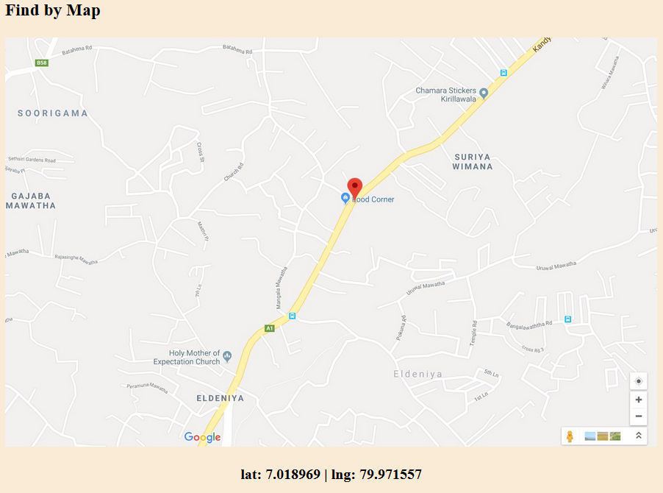

## Contact by sending an Email

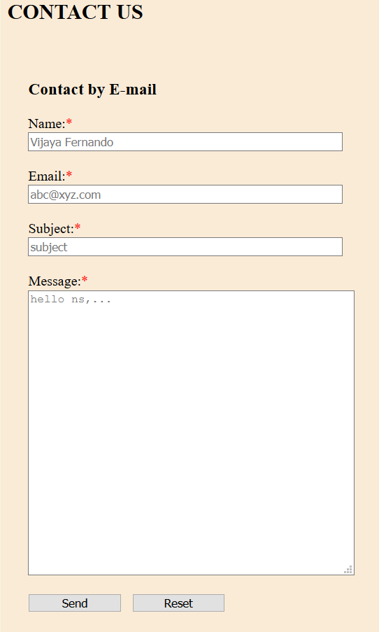

# **HTML Pages**

## Index.html

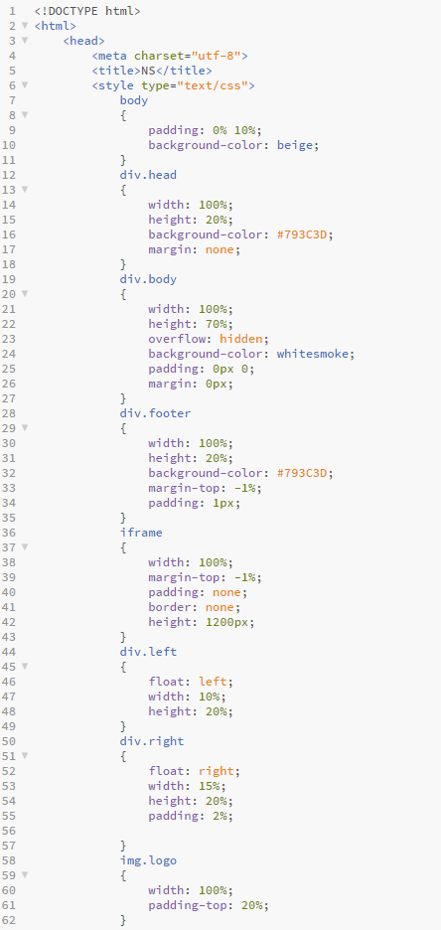

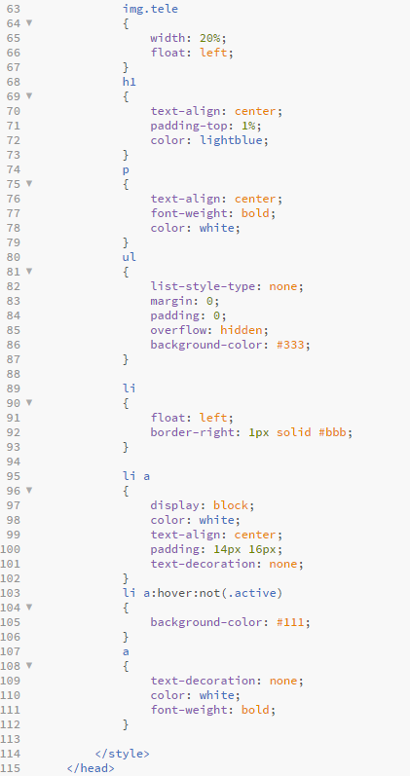

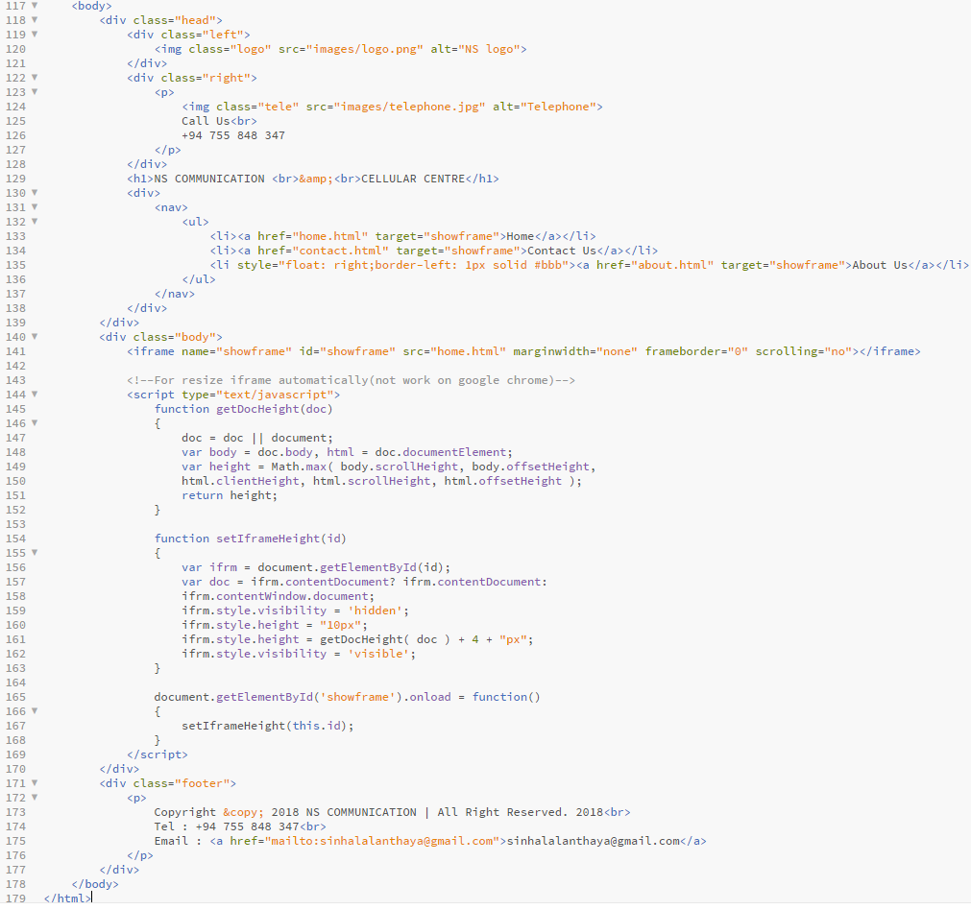

## home.html

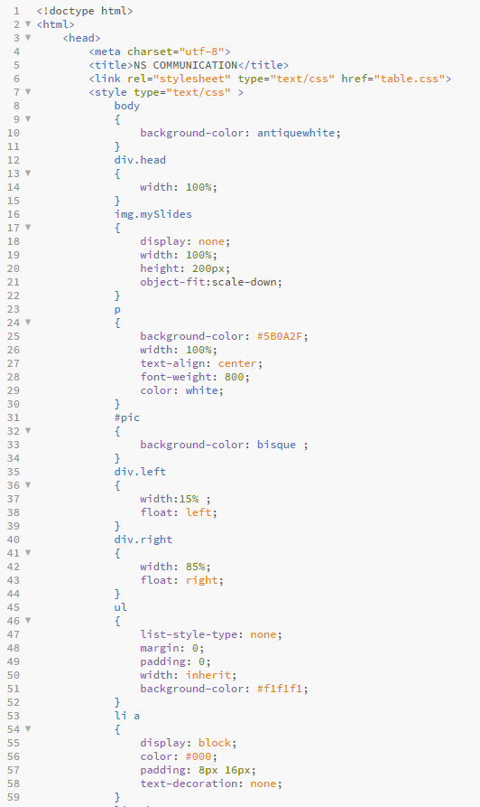

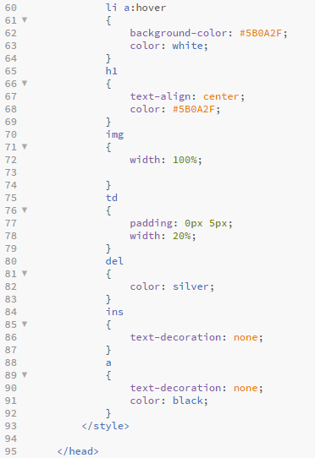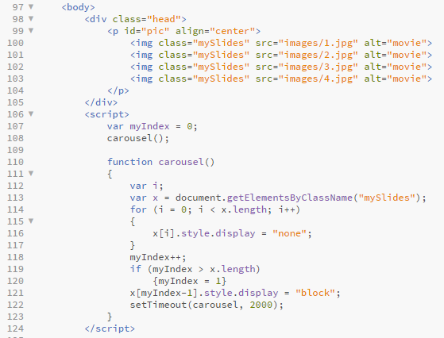

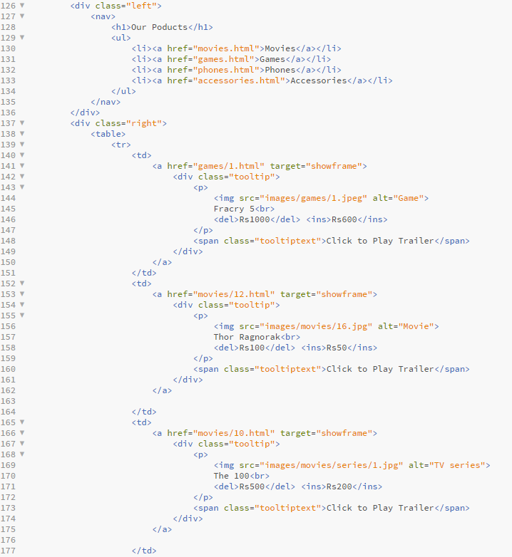

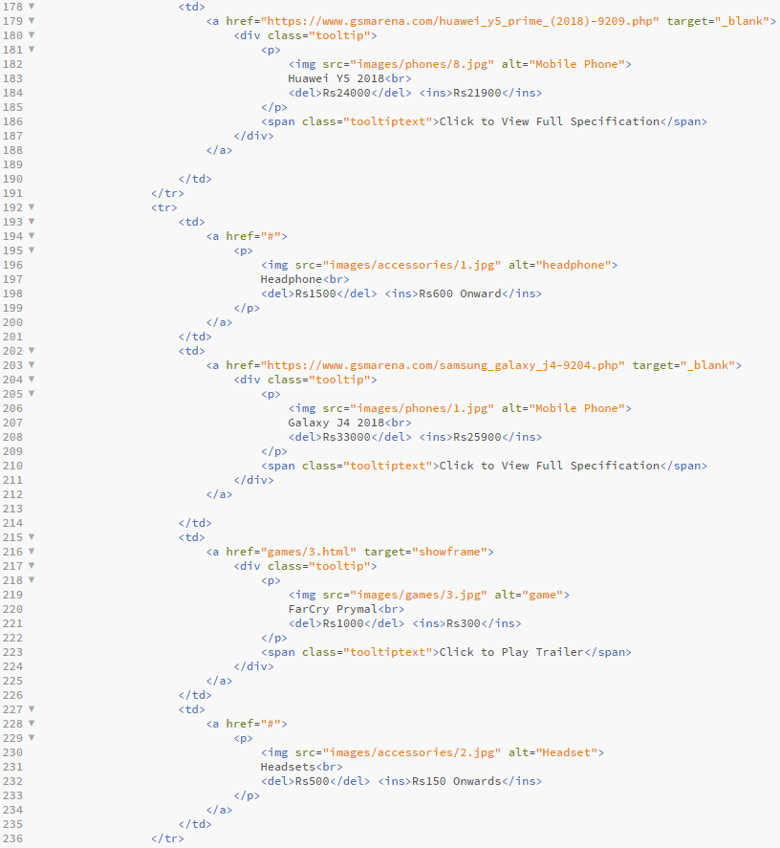

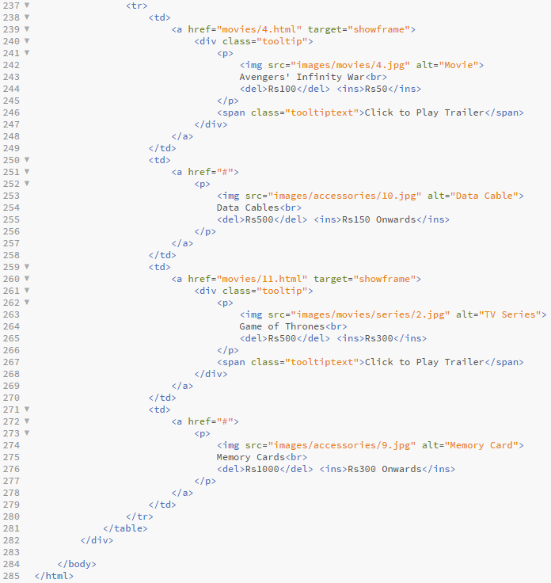

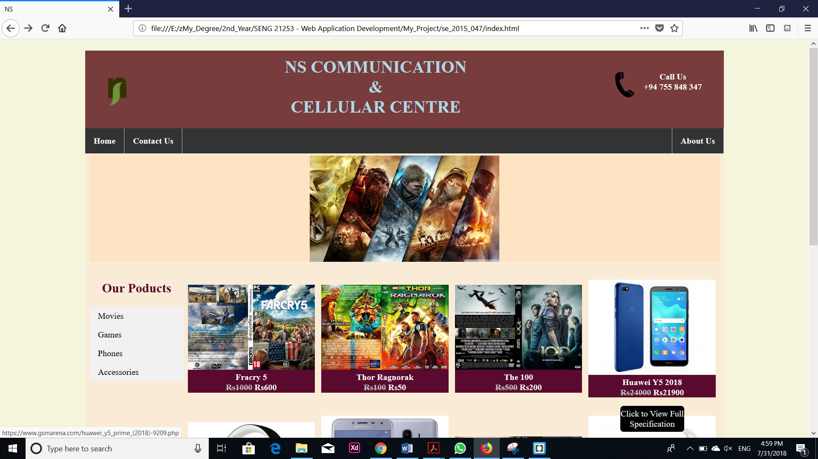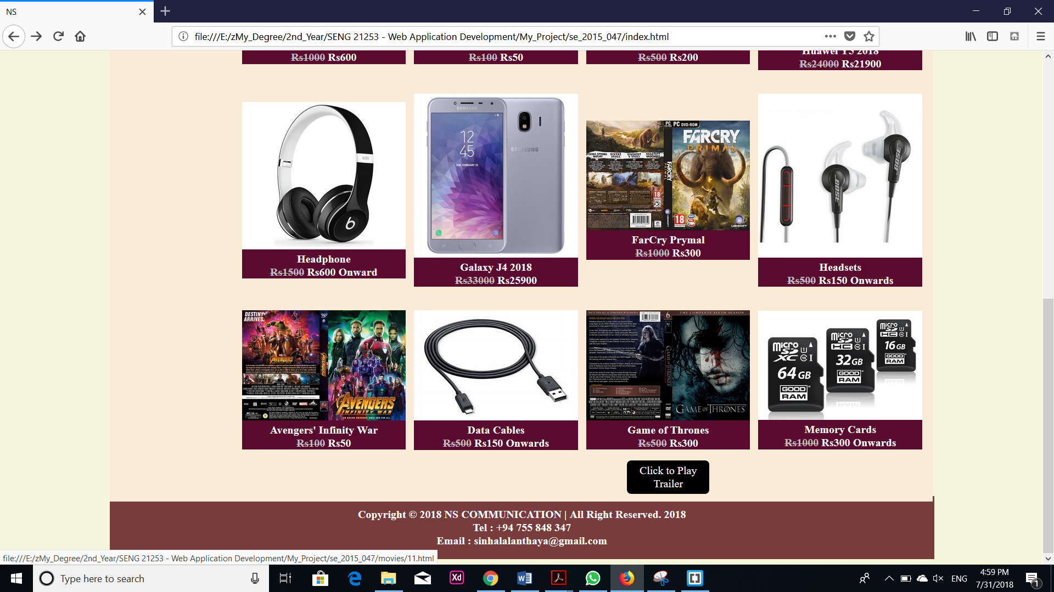

## About.html

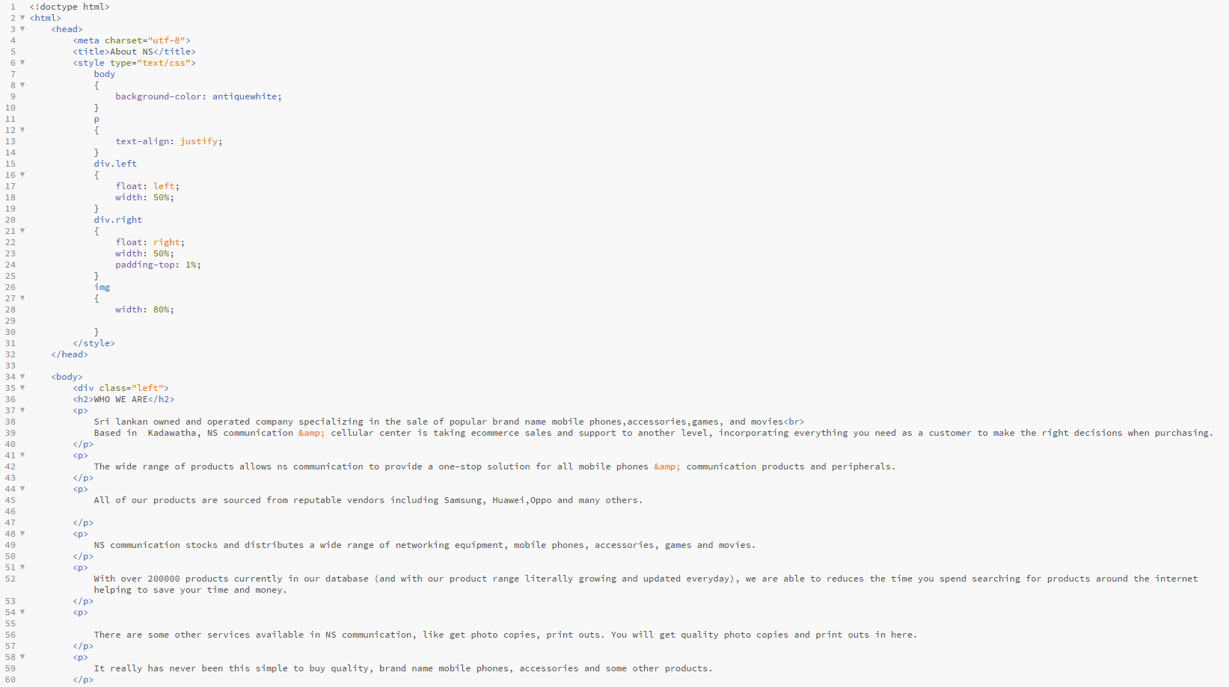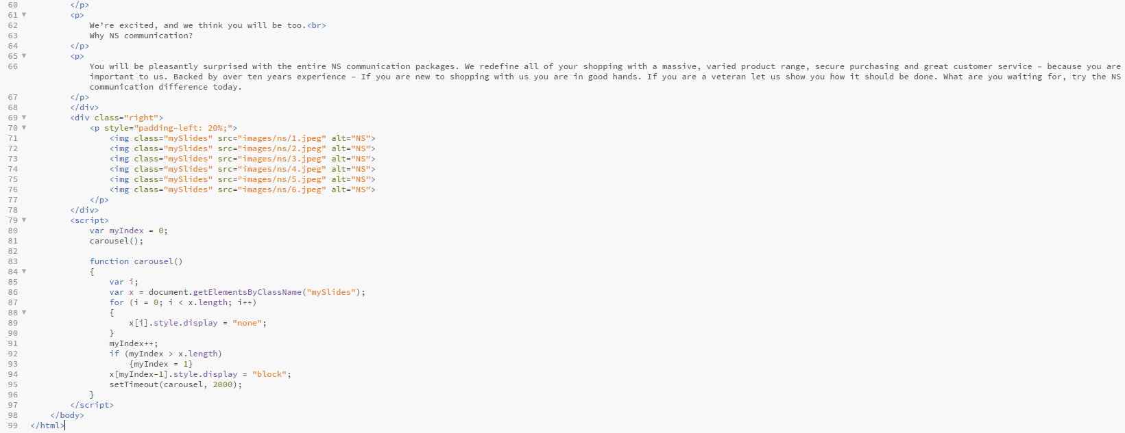

## Contact.html

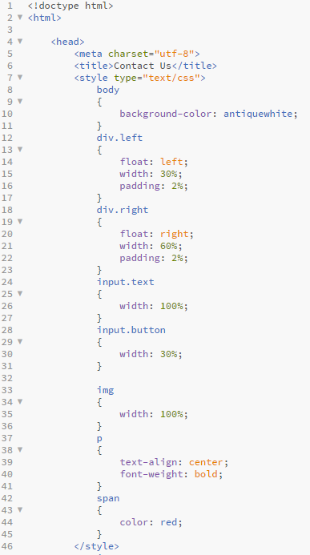

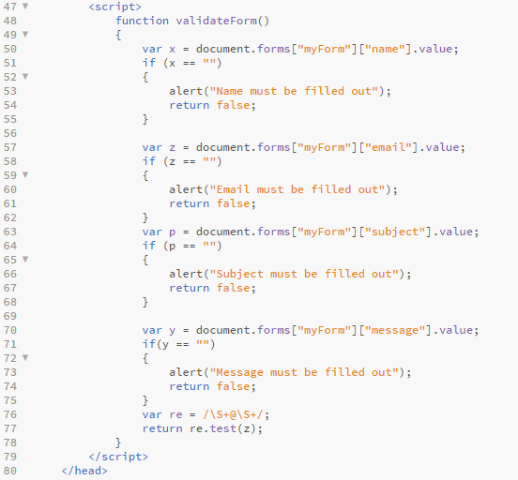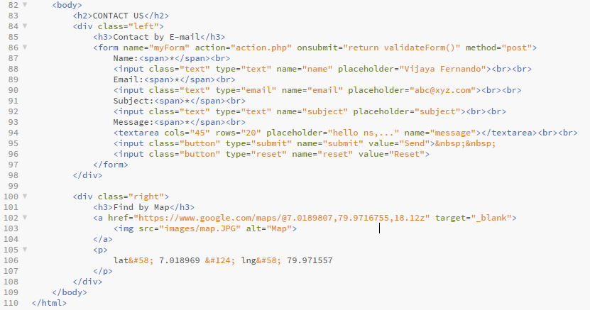

## Movies.html

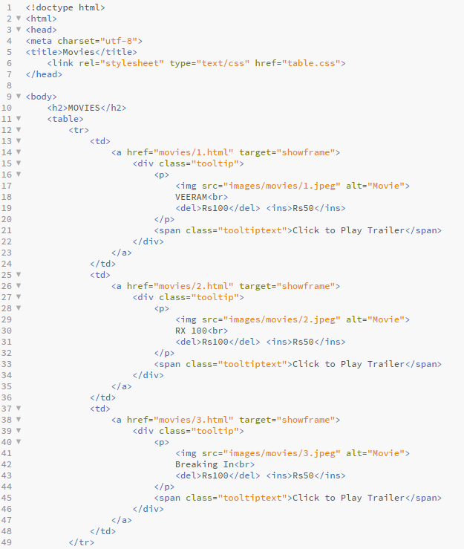

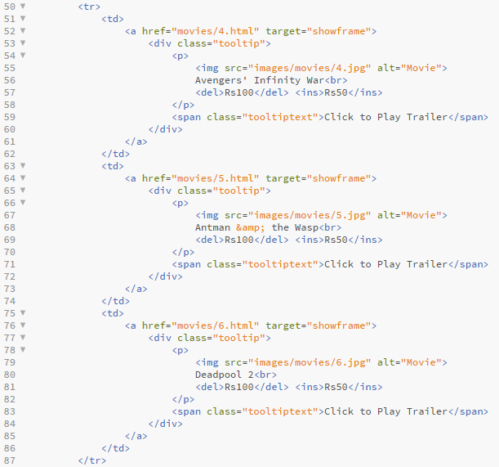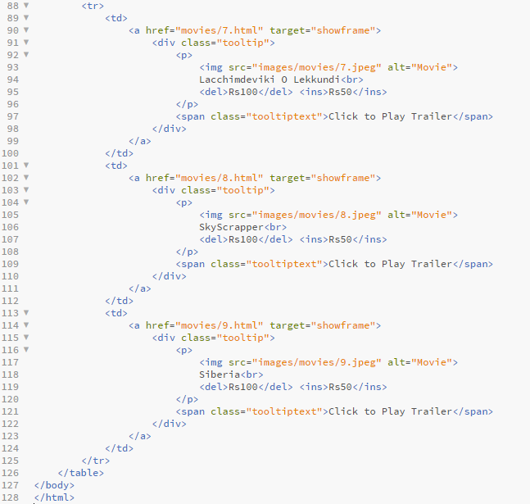

## Games.html

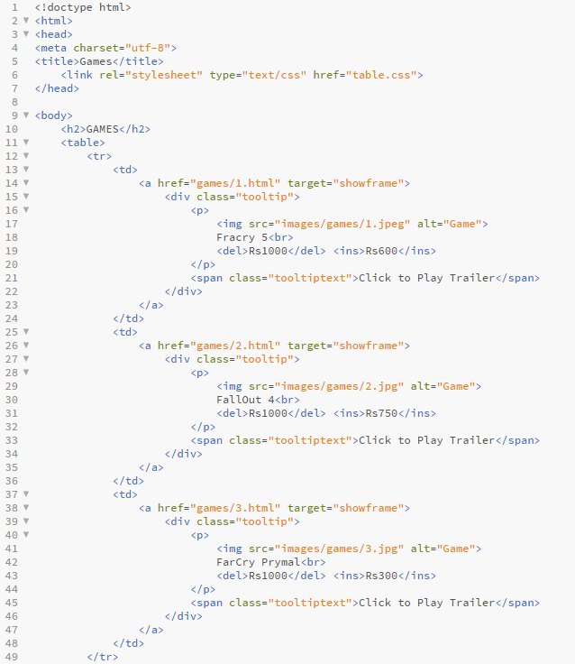

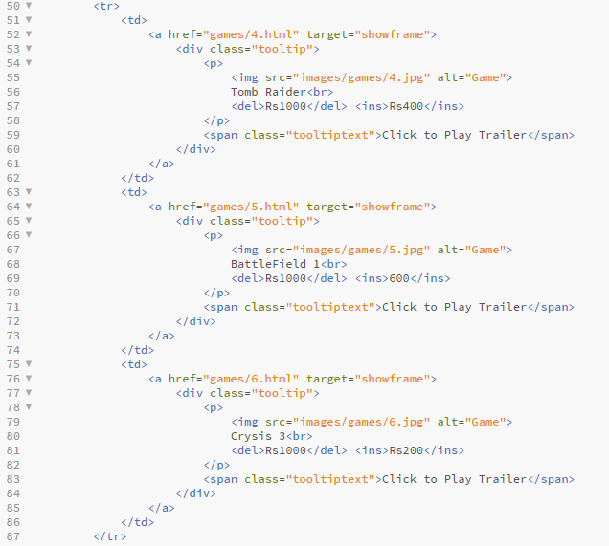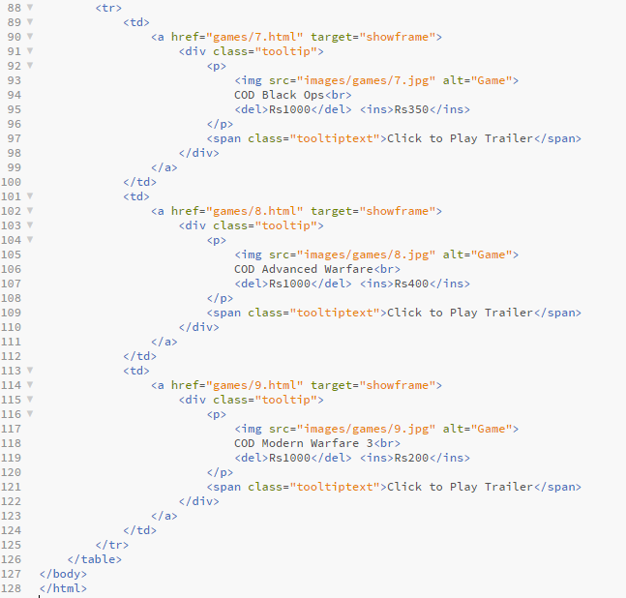

## Phone.html

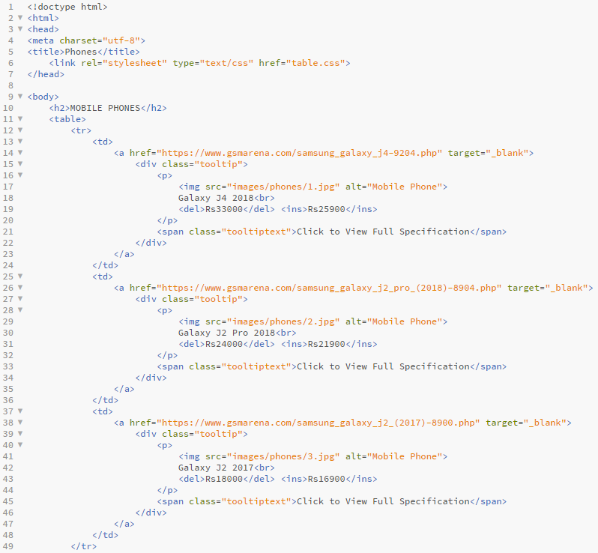

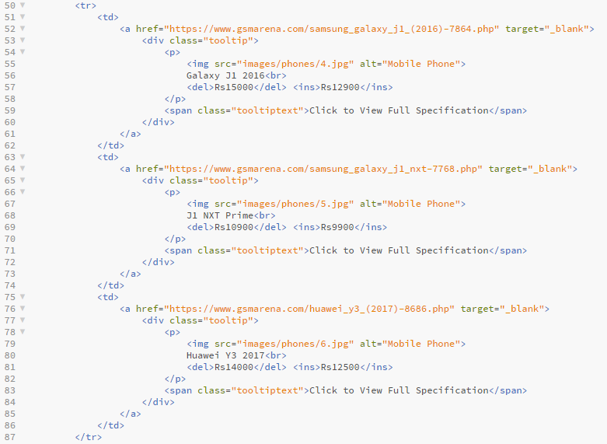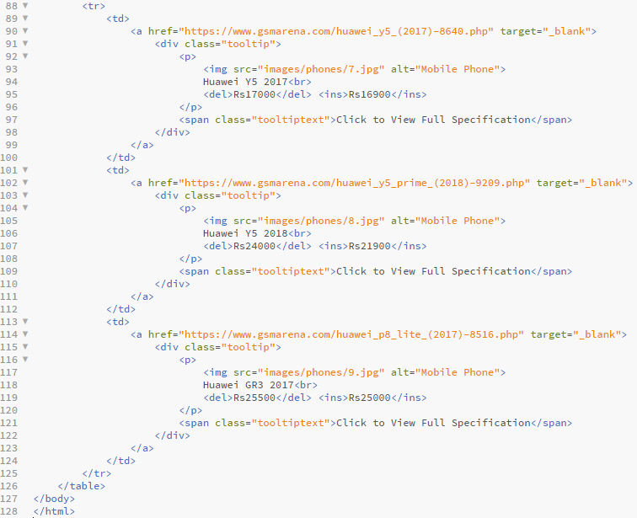

## Accessories.html

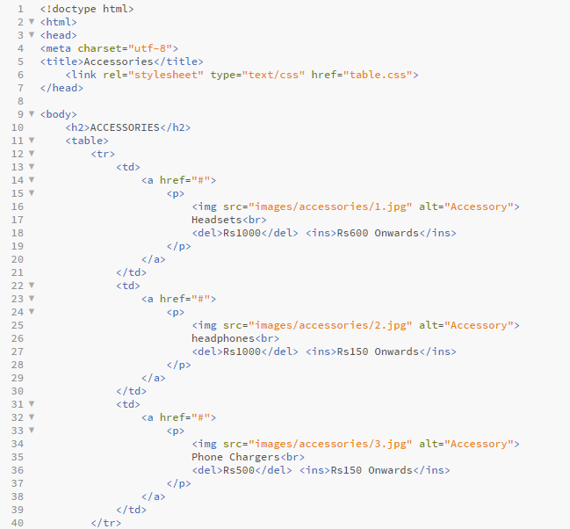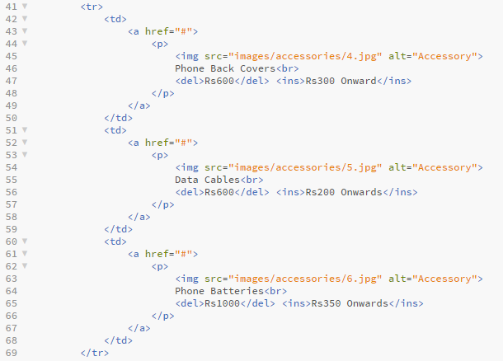

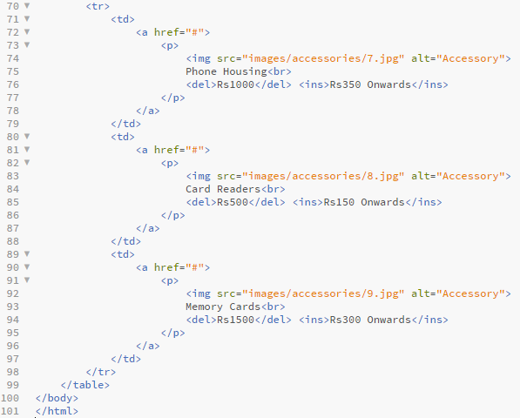

## Table.css

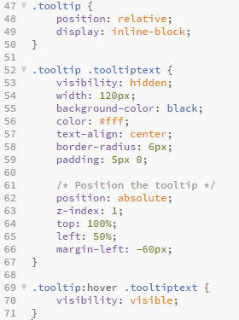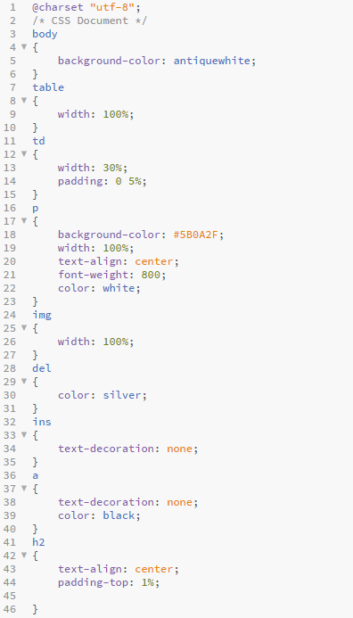

## Action.php

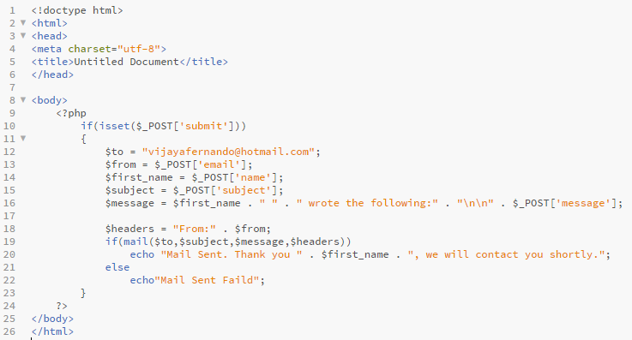

## Movies(1 - 12.html) & Games(1 – 9.html)

